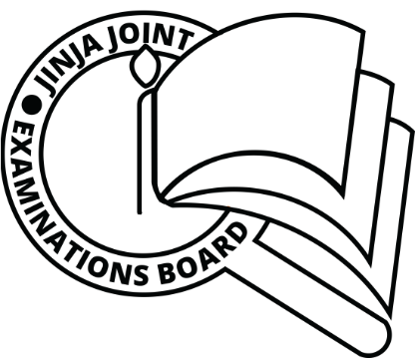**JINJA JOINT EXAMINATIONS BOARD**

**MOCK EXAMINATIONS 2022**

**FINE ART ( STUDIO TECHNOLOGY)**

**P615/4**

**MARKING GUIDE 2022**

**Dominance is;**

**1 a) The attractiveness and boldness of different forms or elements of art to attract viewers.**

b). **Harmony** is the use of similar elements throughout the artwork and it simplifies the look of an artwork.

c) **Rhythm** is created when elements of design are repeatedly used to create a feeling of organized movement.

d) **Pattern** is referred to consistency of color or lines all over the work of art.

e) **Movement** is the action or the path that allows the viewers to follow the work of art.

**2. a) Texture is the smoothness or roughness of the surface quality.**

- Smooth or rough, flat or bumpy, fine or coarse

**b) i) uses of texture:**

* They suggest movement
* Help in the expression of ideas, imagination and feelings.
* To create an illusion of depth and space.
* To describe form.

**3. a) Slip-clay in liquid form.**

b) Kneading is a stage in clay preparation for shaping.

c) Green ware is referred to as unfired clay art works.

d) Terracotta is unglazed fired, reddish brown hard clay pottery products.

e) Grog is the fired crushed powdered clay.

**4. a) Clay is a product of geological rock weathering of the earth formed by decomposition-**

Is a fine earth material, plastic when its wet and hard when its burnt.

b) i) primary clay is clay in its original source of formation also refered to as residual.

ii) Secondary clay has been washed away by erosion from its original source also refered to as sedimentary.

**5. Values of having knowing about clay**

i) To gain satisfaction in the production

ii) To help in development of skills

iii) To promote creativity and imagination

iv) To help in the development of senses especially the sense of touch and sight.

**6. Five method used in pottery production**

1. Pinching with thumb and forefinger to form shape of an object from a ball or lump of clay.
2. Coiling by rolling up clay into coils which are joined to create a shape.
3. Slabing by rolling clay to form slabs which are cut to make desired shapes and joined together by use of slip.
4. Casting with the help of amould to form a final product.
5. Wheel method with a potter’s wheel either manual or electronic.

**7. Six importance of lines and dots**

1. Create an illusion of depth
2. They outline shapes by shading
3. Create moods, express feelings, movement during drawing
4. Create distance
5. Enclose shapes

**8. Terminologies applied to weaving**

Weft thread – horizontally wooven materials in a fabric.

Warp threads – vertically wooven materials in a fabric

A shed – space between the yarns

Yarns materials for interlacing of the weft and warp threads

A shuttle –a tool used to pack the yarns and hold the wefts materials.

A loom - a device for stretching the warp threads and keep them on tension to interlace the weft threads.

**9. Three disadvantages of using paper in sculpture**

It gets destroyed in a wet environment

It can be spoiled by insects and rodents

It needs much long preparation process to be used as a finished product.

**10. Four importance of sculpture production in Uganda**

Maintenance of religious a ffiliation to promote peace, unity, espect and reconciliation among people.

Sources of income for the artists and the nation especially for sales and taxes.

They preserve people’s cultures i.e sculpture for kings, totems for clans.

For easy communication and study purposes.

**END**